PHYSICAL FEATURES OF INDIA
Introduction:
India is a vast country with varied land forms. Our country has practically all major physical features of the earth, i.e., mountains, plains, deserts, plateaus and islands.
Formation of the Physical Features:
- There are different types of rocks; some are very hard, like marble and are very soft like soap stone.
- The colour of soil varies from one place to the other because soil is formed out of different types of rocks.
- Most of these variations are caused due to differences in rock formations.
- The relief features of India are formed by geological formations, weathering, erosion and deposition, have created and modified the relief to its present form.
- Earth scientists have attempted to explain the formation of physical features with the help of some theories based on certain evidences.
- According to ‘Theory of Tectonics’, the crust of the earth has been formed out of seven major and some minor plates.
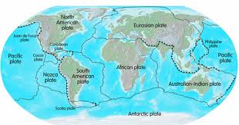
- Due to the movement of the plates, stresses are caused within the plates and the continental rocks above.
- This leads to folding, faulting and volcanic activity.
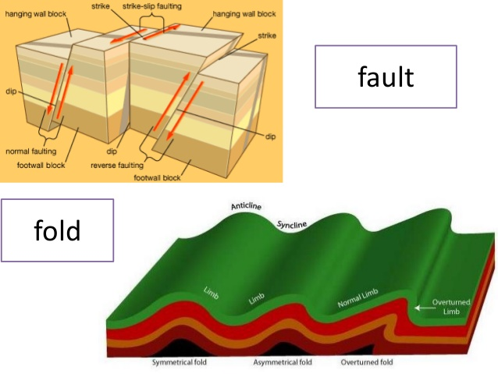
- Folding- When rock strata are layered and subjected to compressional forces, they are deformed by being bent in a process called as folding.

- Faulting- When the rocks are subjected to tensional forces, they are stretched in opposition. Due to this rocks get fractured. This process is called as faulting.
According to the “Theory of plate Tectonics” there are three types of plate movements-
- Some plates come towards each other they form convergent boundary.

When two plates come together, they either collide and crumble, or one may slide under the other.
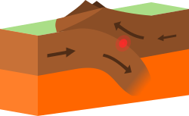

- Sometimes plates moves away from each other, then they form
divergent boundaries.
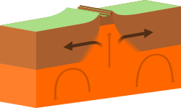
- At times, they may also move horizontally passing each other and form transform boundary.
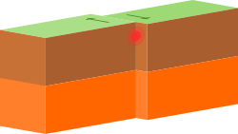
Oldest landform – Himalayas
- The oldest landmass was a part of the Gondwana land which included India, Australia, South Africa, South America and Antarctica as one single land mass.
- Due to convectional currents, this land mass split into a number of pieces.
- The Indo-Australian plate drifted apart and moved towards north.
- This resulted in the collision of the Indo-Australian plate with the European Plate.
- Due to this collision, the Tethys, were folded and the Himalayas were formed.
- Tethys refers to shallow sea having less depth.
Formation of the Northern Plains:
- The uplifting of the Himalayas resulted in the formation of a large basin.
- Gradually this basin got filled with the sediments by the rivers flowing from the mountains.
- A flat land of extensive alluvial deposits led to the formation of the northern plains of India.
Major physiographic divisions:
On the basis of physical features, we can have the following physiographic divisions of India:-
- The Himalayan Mountains
- The Northern Plains
- The Peninsular Plateau
- The Indian Desert
- The Coastline Plains
- The Islands
- The Himalayan Mountains
- They are geologically young and structurally fold mountains.
- They stretch over the northern borders of India.
- These mountain ranges run in a west-east direction from the Indus to the Brahmaputra. The Himalayas covers a distance of about 2,400 Km. Their width varies from 400 Km in Kashmir to 150 Km in Arunachal Pradesh.
The Himalaya consists of three parallel ranges in its longitudinal extent.
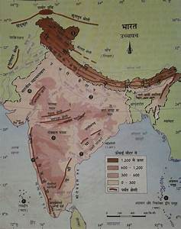
The Greater or the Inner Himalayas:
- This is the northern-most range also called the Himadri.
- It is the most continuous range consisting of the loftiest peaks with an average height of 6,000 metres.
- All prominent Himalayan peaks lie here.
- They are asymmetrical in nature.
- The core is composed of granite.
- It is perennially covered with snow, and a number of glaciers descend from this range.
The Lesser Himalayas or Himachal:
- This range lies to the south of the Himadri and forms the most rugged mountain system.
- The ranges are mainly composed of highly compressed and altered rocks.
- The altitude varies between 3,700 and 4,500 metres and the average width is of 50 Km.
- The Pir Panjal range forms the longest and the most important range.
- The range consists of the famous valley of Kashmir, the Kangra and Kullu Valley in Himachal Pradesh.
- This region is well-known for its hill stations.
The Shiwaliks:
- This is the outer-most range of the Himalayas.
- They extend over a width of 10-50 Km.
- They have an altitude varying between 900 and 1100 metres.
- These ranges are composed of unconsolidated sediments brought down by rivers from the main Himalayan ranges located farther north.
- These valleys are covered with thick gravel and alluvium.
- The longitudinal valley lying between lesser Himalaya and the Shiwaliks are known as Duns.
- Dehra Dun, Kotli Dun and Patli Dun are some of the well-known Duns.
Regional Division of the Himalayas:
Besides the longitudinal divisions, the Himalayas have been divided on the basis of regions from west to east.
These divisions have been demarcated by river valley.
- The part lying between Indus and Satluj are traditionally known as Punjab Himalaya or regionally as Kashmir and Himachal Himalaya from west to east respectively.
- The part of the Himalayas lying between Satluj and Kali rivers in known as Kumaon Himalayas.
- The Kali and Teesta rivers demarcate the Nepal Himalayas.
- The part lying between Teesta and Dihang rivers is known as Assam Himalayas.
- The Brahmaputra marks the eastern-most boundary of the Himalayas.:
- Beyond the Dihang gorge, the Himalayas bend sharply to the south and spread along the eastern boundary of India.
- They are known as the Purvanchal or the Eastern hills and mountains.
- These hills run through the north-eastern states.
- They are mostly composed of strong sandstones, which are sedimentary rocks.
- They are covered with dense forests and run as parallel ranges and valley.
- The Purvachal comprises the Patkai hill, the Naga hills, the Manipur hills and the Mizo hills.

- The Northern Plains

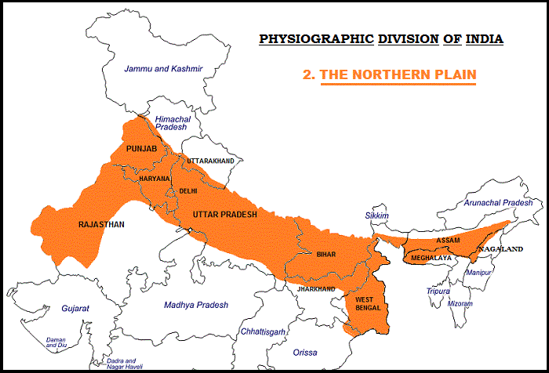
- The northern plain has been formed by the three major river systems, namely – the Indus, the Ganga and the Brahmaputra along with their tributaries.
- Tributaries- Small rivers or streams that join the main rivers are called as tributaries.
- This plain is formed of alluvial soil.
- The plain covers the area about 7 lakh sq. km.
- The plain is about 2400 km long and 240 to 320 km broad, is a densely populated area.
- The northern plains are favourable for agriculture because of a rich soil cover, adequate water supply and favourable climate.
- As the velocity of the river decreases in the middle course, riverine islands are formed.

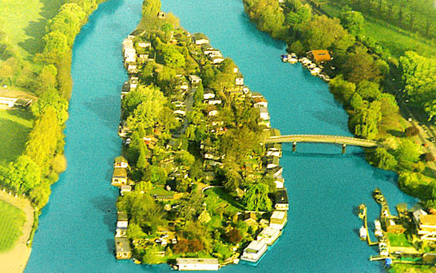

- Majuli, in the Brahmaputra is the largest inhabited riverine island in the world.
- The rivers in their lower course split into numerous channels called distributaries due to the deposition of silt.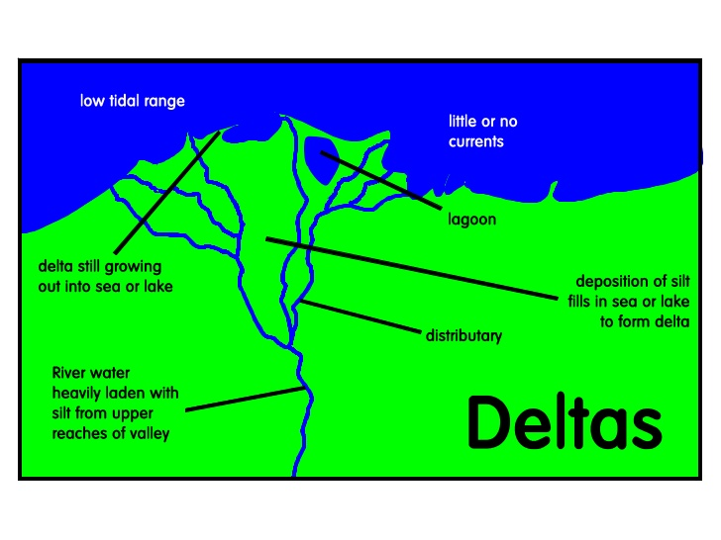
- The Northern Plain is broadly divided into three sections.
(1) The Punjab Plains:
- The Western part of the Northern Plain is referred to as the Punjab Plains.
- This part is formed by the Indus and its tributaries.
- A larger part of this plain lies in Pakistan.
- The Indus and its tributaries – the Jhelum, the Chenab, the Ravi, the Beas and the Satluj originate in the Himalaya.
- This section of the plain is dominated by the doabs.
(2) The Ganga Plains:
- The Ganga plain extends between Ghaggar and Teesta rivers.
- It is spread over the states of North India, Haryana, Delhi, U.P., Bihar, Jharkhand and West Bengal to its East.
(3) The Brahmaputra Plain:
- This part particularly lies in Assam.

The main relief features of the Northern Plains:
The northern plains are generally described as flat land with no variation in relief features. It is actually not true.
According to the variations in relief features the Northern plain can be divided into four regions-
- Bhabar:
- This is formed by the deposition of pebbles by the rivers that descends from the mountains.
- It is a narrow belt of about 8 to 16 km in width lying parallel to the slopes of the Shiwaliks.
- All the streams disappear in this bhabar belt.

- Terai:
- This is the region where the streams and rivers re-emerge and create a wet, swampy and marshy region.
- This was a thickly forested region full of wildlife which have been cleared to create agricultural land and to settle migrants from Pakistan after partition.
- Bhangar:
- This is the largest part of the northern plain and is formed of older alluvium.
- It lies above the floodplains of the rivers and presents a terrace-like feature.
- The soil in this region contains calcareous deposits, locally known as kankar.
- Khadar:
- These are newer, younger deposits of the floodplains.
- They are renewed almost every year and are ideal for intensive agriculture.

- The Peninsular Plateau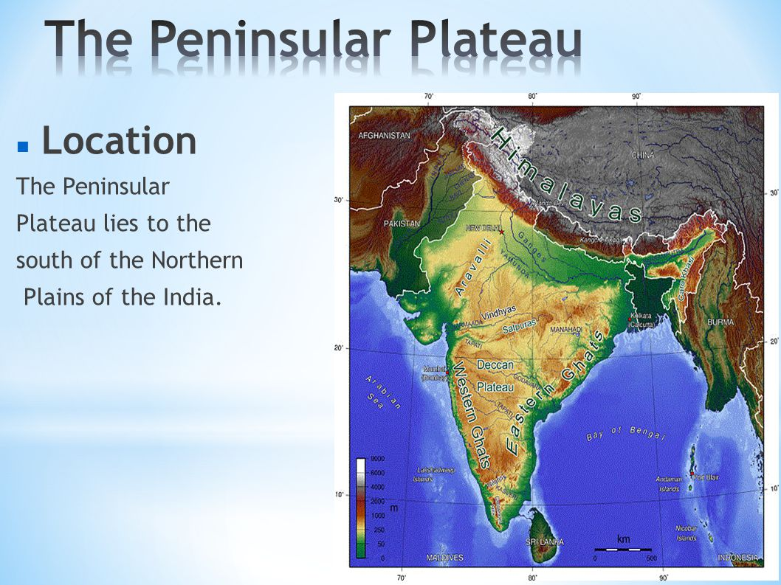
- It is a tableland composed of the old crystalline, igneous and metamorphic rocks.
- It was formed due to the breaking and drifting of the Gondwana land.
- The plateau has broad and shallow valleys and rounded hills.
- This plateau consists of two broad divisions.
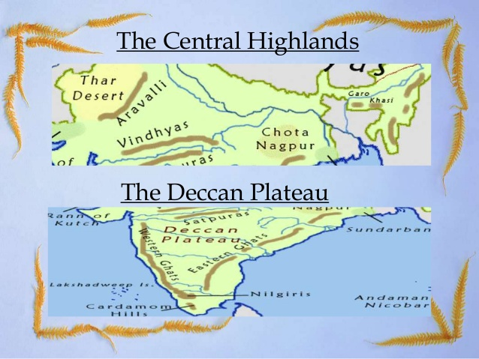
The Central Highlands:
- This part lies to the north of the Narmada River and covers a major area of the Malwa plateau.
- The Vindhyan range is bounded by the central Highlands on the south and the Aravalis on the northwest.
- Towards the west it gradually merges with the sandy and rocky desert of Rajasthan.
- The rivers here are Chambal, the Sind, the Betwa and the Ken.
- The Central Highlands are wider in the west but narrower in the east.
- The eastward extensions of this plateau are locally known as the Bundelkhand and Baghelkhand.
- The Chotanagpur plateau marks the further eastward extension, drained by the Damodar river.
The Deccan Plateau:
- It is a triangular landmass that lies to the south of the river Narmada.
- The Satpura range flnks its broad base in the north while the Mahadev, the Kaimur hills and the Maikal range form its eastern extensions.
- The Deccan Plateau is higher in the west and slopes gently eastwards.
- The Plateau extends to the northeast and is known as the Meghalaya, Karbi-Anglong Plateau and North Cachar Hills.
- It is separated by a fault from the Chotanagpur Plateau.
- Three prominent hill ranges from the west to the east are the Garo, the Khasi and the Jaintia Hills.
- The Deccan plateau is marked by the Western and Eastern edges.
Western Ghats
- Western Ghats lie parallel to the western coast.
- They are continuous and can be crossed through passes only.
- The Western Ghats are higher than the Eastern Ghats.
- Their average elevation is 900-1600 metres.
- The Western Ghats cause orographic rain by facing the rain bearing moist winds to rise along the western slopes of the Ghats.
- The height of the Western Ghats progressively increases from north to south.
- The highest peaks include the Anai Mudi (2,695 metres) and the Doda Betta (2,637 metres).
Eastern Ghats
- The average elevation of the Eastern Ghats is 600 metres.
- The Eastern Ghats stretch from the Mahanadi Valley to the Nilgiris in the south.
- They are discontinuous and irregular and dissected by rivers draining into the Bay of Bengal.
- Mahendragiri (1,501 metres) is the highest peak in the Eastern Ghats.
- Shevroy Hills and the Javadi Hills are located to the southeast of the Eastern Ghats.
Black Soil
- The Peninsular plateau is known for the black soil area called the Deccan Trap.
- This is of volcanic origin; hence, the rocks are igneous.

The Aravali Hills
- The Aravali Hills lie on the western and northwestern margins of the peninsular plateau.
- These are highly eroded hills and are found as broken hills.
- They extend from Gujarat to Delhi in a southwest-northeast direction.
- The Indian Desert
- It lies towards the western margins of the Aravali Hills.
- It is a sandy plain covered with sand dunes.
- This region receives very low rainfall below 150 mm per year.
- It has arid climate with low vegetation cover.
- Streams appear during the rainy season.
- Luni is the only large river in this region.
- Barchans cover larger areas but longitudinal dunes become more prominent near the Indo-Pakistan boundary.
- The Coastal Plains
- These are stretch of narrow coastal strips, running along the Arabian Sea on the west and the Bay of Bengal on the east.
- The western coast, between the Western Ghats and the Arabian Sea, is narrow plain.
- It consists of three sections.
- The northern part of the coast is called the Konkan (Mumbai –Goa).
- The central stretch is called the Kannad Plain.
- The southern stretch is referred to as the Malabar Coast.
- The plains along the Bay of Bengal are wide and level.
- In the northern part, it is called the Northern Circar.
- The southern part is known as the Coromandel Coast.
- Large rivers, such as the Mahanadi, the Godavari, the Krishna and the Kaveri have formed extensive delta on this coast.
- Lake Chilika is an important feature along the eastern coast. It is the largest salt water lake in India. It lies in the state of Odisha, to the south of the Mahanadi delta.
- The Islands
Lakshadweep Islands:
- This group of islands is comprised of small coral islands.
- It covers small area of 32 sq km.
- Kavaratti island is the administrative headquarters of Lakshadweep.
- The Pitti island, which is uninhabited, has a bird sanctuary.
Andaman and Nicobar Islands:
- These are the elongated chain of islands located in the Bay of Bengal.
- They are bigger in size and are more numerous and scattered.
- The Andaman lies in the north and the Nicobar in the south.
- These islands lie close to equator and experience equatorial climate and have thick forest cover.
- India’s only active volcano is found on Barren island in Andaman and Nicobar group of islands.

Solutions for class 9 Geography SST Chapter 2 Physical features of India
Question-1
What are Tectonic Plates?
Solution:
The crust (upper part) of the earth has been formed out of seven major and some minor plates. These are called tectonic plates.
A Tectonic plate (also called lithospheric plate) is a massive, irregularly shaped slab of solid rock, generally composed of both continental and oceanic lithosphere. Plate size can vary greatly, from a few hundred to thousands of kilometers across; the Pacific and Antarctic Plates are among the largest. Plate thickness also varies greatly, ranging from less than 15 km for young oceanic lithosphere to about 200 km or more for ancient continental lithosphere.
Formulae Handbook for Class 9 Maths and Science Educational Loans in India
Question-2
Which continents of today were part of the Gondwana land?
Solution:
The oldest landmass, (the Peninsula part), was a part of the Gondwana land. The Gondwana land included India, Australia, South Africa and South America as one single land mass.
Question-3
What is the bhabar?
Solution:
The rivers, after descending from the mountains deposit pebbles in a narrow belt of about 8 to 16 km in width lying parallel to the slopes of the Shiwaliks. It is known as bhabar.
Question-4
Distinguish Between Converging and Diverging Tectonic Plates
Solution:
Converging Tectonic Plates
Some plates come towards each other and form convergent boundary.
Diverging Tectonic Plates
Some plates move away from each other and form divergent boundary.
Question-5
Distinguish Between Bhangar and Khadar
Solution:
Bhangar:
The largest part of the northern plain is formed of older alluvium They lie above the flood plains of the rivers and present a terrace like feature. This part is known as bhangar.
Khadar:
The soil in this region contains calcareous deposites locally known as kankar. The newer, younger deposits of the flood plains are called khadar. They are renewed almost every year and so are fertile, thus, ideal for intensive agriculture.
Question-6
Distinguish Between Western Ghats and Eastern Ghats
Solution:
Western Ghats:
The Western Ghats are higher than the Eastern Ghats. Their average elevation is 900– 1600 metres as against 600 metres of the Eastern Ghats. The Western Ghats cause orographic rain by facing the rain bearing moist winds to rise along the western slopes of the Ghats. The Western Ghats are known by different local names. The height of the Western Ghats progressively increases from north to south. The highest peaks include the Anai Mudi (2,695metres) and the Doda Betta (2,637 metres).
Eastern Ghats:
The Eastern Ghats stretch from the Mahanadi Valley to the Nigiris in the south. The Eastern Ghats are discontinuous and irregular and dissected by rivers draining into the Bay of Bengal. Mahendragiri (1,501 metres) is the highest peak in the Eastern Ghats. Shevroy Hills and the Javadi Hills are located to the southeast of the Eastern Ghats.
Question-7
Describe how the Himalayas were formed.
Solution:
The Himalayas and the Northern Plains are the most recent landforms. From the viewpoint of geology, Himalayan Mountains form an unstable zone. The whole mountain system of Himalaya represents a very youthful topography with high peaks, deep valleys and fast flowing rivers. The northern plains are formed of alluvial deposits. The peninsular plateau is composed of igneous and metamorphic rocks with gently rising hills and wide valleys.
Question-8
Which are the major physiographic divisions of India? Contrast the relief of the Himalayan region with that of the Peninsular plateau.
Solution:
The physical features of India can be grouped under the following physiographic divisions:
(i) The Himalayan Mountains
(ii) The Northern Plains
(iii) The Peninsular Plateau
(iv) The Indian Desert
(v) The Coastal Plains
(vi) The Islands
The Himalaya consists of three parallel ranges in its longitudinal extent. A number of valleys lie between these ranges. The northern most range is known as the Great or Inner Himalayas or the ‘Himadri’. It is the most continuous range consisting of the loftiest peaks with an average height of 6,000 metres. It contains all the prominent Himalayan peaks.
The Deccan Plateau is a triangular landmass that lies to the south of the river Narmada. The Satpura range flanks its broad base in the north while the Mahadev, the Kaimur hills and the Maikal range form its eastern extensions. Locate these hills and ranges in the physical map of India. The Deccan Plateau is higher in the west and slopes gently eastwards. An extension of the Plateau is also visible in the northeast– locally known as the Meghalaya and Karbi-Anglong Plateau. It is separated by a fault from the Chotanagpur Plateau. Three Prominent hill ranges from the west to east are the Garo, the Khasi and the Jaintia Hills.
Question-9
Give an account of the Northern Plains of India.
Solution:
The northern plain has been formed by the interplay of the three major river systems, namely– the Indus, the Ganga and the Brahmaputra along with their tributaries. This plain is formed of alluvial soil. The deposition of alluvium in a vast basin lying at the foothills of the Himalaya over millions of years, formed this fertile plain. It spreads over an area of 7 lakh sq. km. The plain being about 2400 Km long and 240 to 320 Km broad is a densely populated physiographic division. With a rich soil cover combined with adequate water supply and favourable climate it is agriculturally a very productive part of India. The rivers in their lower course split into numerous channels due to the deposition of silt. These channels are known as distributaries. The Northern Plain is broadly divided into three sections. The Western part of the Northern Plain is referred to as the Punjab Plains. Formed by the Indus and its tributaries, the larger part of this plain lies in Pakistan. The Indus and its tributaries–the Jhelum, the Chenab, the Ravi, the Beas and the Satluj originate in the Himalaya. This section of the plain is dominated by the doabs.
Question-10
Write short notes on the following.(i) The Indian Desert, (ii) The Central Highlands
(iii) The Island Groups of India
Solution:
(i) The Indian Desert
The Indian desest lies towards the western margins of the Aravali Hills. It is an undulating sandy plain covered with sand dunes. This region receives very low rainfall below 150 mm per year. It has arid climate with low vegetatin cover. Streams appear during the rainy season. Soon after they disappear into the sand as they do not have enough water to reach the sea. Luni is the only large river in this region. Barchans (crescent shaped dunes) cover larger areas but longitudinal dunes become more promiment near the Indo-Pakistan boundary.
(ii) The Central Highlands
The Peninsular plateau consists of two broad divisions, namely, the Central Highlands and the Deccan Plateau. The part of the Peninsular plateau lying to the north of the Narmada river covering a major area of the Malwa plateau is known as the Central Highlands. The Vindhyan range is bounded by the Central Highlands on the south and the Aravalis on the northwest. The further westward extension gradually merges with the sandy and rocky desert of Rajasthan.
The flow of the rivers draining this region, namely the Chambal, the Sind, the Betwa and Ken is from southwest to northeast, thus indicating the slope. The Central Highlands are wider in the west but narrower in the east. The eastward extensions of this plateau are locally known as the Bundelkhand and Baghelkhand. The Chotanagpur plateau marks the further eastward extension, drained by the Damodar river.
(iii) The Island Groups of India
This group of islands is composed of small coral islands. Earlier they were known as Laccadive, Minicoy and Amindive. In 1973 these were named as Lakshadweep. It covers small area of 32 sq km. Kavaratti island is the administrative headquarters of Lakshadweep.
This island group has great diversity of flora and fauna. The Pitli Island, which is uninhabited, has a bird sanctuary. An elongated chain of islands located in the Bay of Bengal extending from north to south. These are Andaman and Nicobar islands. They are bigger in size and are more numerous and scattered. The entire group of islands is divided into two broad categories – The Andaman in the north and the Nicobar in the south. It is believed that these islands are an elevated portion of submarine mountains. These island groups are of great starategic importance for the country. There is great diversity of flora and fauna in this group of islands too. These islands lie close to the equator and experience equatorial climate and has thick forest cover.

Physical Features of India Class 9 Extra Questions Short Answer Type Questions
Question 1.
How the Himalayas have been divided on the basis of regions from west to east?
Answer:
- Punjab Himalayas: These divisions have been demarcated by river valleys. The part of Himalayas lying between Indus and Satluj has been traditionally known as Punjab Himalaya, but it is also known regionally as Kashmir and Himachal Himalaya from west to east respectively.
- Kumaon Himalayas: The part of the Himalayas lying between Satluj and Kali rivers is known as Kumaon Himalayas.
- Nepal Himalayas: The Kali and Teesta rivers demarcate the Nepal Himalayas.
- Assam Himalayas: the part lying between Teesta and Dihang rivers is known as Assam Himalayas.
Question 2.
Which are the three main ranges of the Himalayas?
Answer:
The Himalayas have three ranges which run almost parallel to each other. The distance between these ranges is wider in the west and becomes narrow in the east.
These ranges are—
- the Outer Himalayas or the Shiwalik Range
- the Middle Himalayas or the Himachal Range and
- the Inner or Great Himalayas or the Himadri.
Question 3.
Describe the “Theory of Plate Tectonics”.
Answer:
Earth scientists have attempted to explain the formation of physical features with the help of some theories based on certain evidences. One such Plausible theory is the ‘Theory of Plate Tectonics’. According to this theory, the crust (upper part) of the earth has been formed out of seven major and some minor plates. The movement of the plates results in the building up of stresses within the plates and the continental rocks above, leading to folding, faulting and volcanic activity
Question 4.
Why is the soil in the Northern Plain fertile?
Answer:
The soil of this plain has been formed by the sediments brought down by the rivers from the Himalayas. Such plain is called an alluvial plain and it is very fertile. This plain is one of the largest and most fertile plains of world. It is the most thickly populated plain. This is also the major crop growing area in India. This plain is drained by river Ganga, Brahmaputra and their tributaries. The slope of this plain in the west is south-west and in the east is south-east.
An area through which a river and its tributaries flow is called its basin.
Question 5.
Which plateau lies between the Aravali and the Vindhya range? Write a brief note on this plateau.
Answer:
The Malwa Plateau lies between the Aravali hills and the Vindhya range. The Aravali hills lie to the west of the plateau and the Vindhya range lies to its south. The part of the peninsular plateau lying to the north of the Narmada river, covering a major area of the Malwa plateau, is known as the Central Highlands.
The Malwa plateau lies in Madhya Pradesh. It is composed of extensive lava flows. There are rolling plains separated by flat-topped hills. The plateau is largely broken in form of ravines near the Chambal Valley in its east.
Question 6.
What do you mean Great Himalayas? Write its two characteristics.
Answer:
The northern most range of the Himalayas is known as the Great or Inner Himalayas or the Himadri.
(a) It is the most continuous range consisting of the loftiest peaks with an average height of 6000 metres. It contains all prominent Himalayan peaks.
(b) Its folds are asymmetrical in nature and its core is composed of granite rock. It is perennially snow bound, and several glaciers descend from this range.
Question 7.
How was the Great Northern Plains of India formed?
Answer:
The formation of the Himalayas due to upliftment of sediments out of the Tethys Sea and subsidence of the northern flank of the Peninsular Plateau resulted in the formation of a large basin. In due course of time this depression, gradually got filled with deposition of sediments by the rivers flowing from the mountains in the north and the peninsular plateau in the south. A flat land of extensive alluvial deposits led to the formation of the northern plains of India.
Question 8.
Write a short note on ‘coral polyps’.
Answer:
Coral polyps are short-lived microscopic organisms, which live in colonies. They flourish in shallow, mud-free and warm waters. They secrete hard rock like substance. The coral secretion and their skeletons from coral deposits in the form of reefs.
They are mainly of three kinds—barrier reef, fringing reef and atolls. The Great Barrier Reef of Australia is a good example of the first kind of coral reefs. Atolls are circular or horse shoe-shaped coral reefs.
Question 9.
Write a short note on the Western Coastal Plains.
Answer:
The Peninsular plateau is flanked by stretch of narrow coastal strips, running along the Arabian Sea on the west and the Bay of Bengal on the east. The western coast, sandwiched between the Western Ghats and the Arabian Sea, is a narrow plain. It consists of three sections. The northern part of the coast is called the Konkan (Mumbai-Goa), the central stretch is called the Kannad Plain while the southern stretch is referred to as the Malabar coast.
Question 10.
Why are the Himalayas called as young mountains?
Answer:
The Himalayas were formed recently in the earth’s history as a result of compression.
The sediments beneath the ocean were folded due to the compression and got uplifted. Therefore, they are known as young fold mountains. These mountains are still rising. The whole mountain represents a very youthful topography with high peaks, deep valleys and fast flowing rivers.
Question 11.
Write any three features of the Shiwalik range.
Answer:
The three features of the Shiwalik range are :
(a) This is the outermost range of the Himalayas.
(b) The average altitude varies from 900 to 1100 metres.
(c) These ranges are composed of unconsolidated sediments brought down by rivers from the main Himalayan ranges.
Question 12.
Describe the river systems of the Northern Plains.
Answer:
The three river systems in the Northern plains from east to west are the Brahmaputra, Ganga and Indus. A large part of the Indus system lies in Pakistan. The Indus and its tributaries – the Jhelum, the Chenab, the Ravi, the Beas and the Satluj originate in the Himalayas. This section of the plain is dominated by the doabs. The Ganga plain extends between the Ghaggar and Teesta rivers. It spreads over the states of Haryana, Delhi, Uttar Pradesh, Bihar, parts of Jharkhand and West Bengal. It has tributaries like the Yamuna, Gomati, Ghaghara, Son, Gandak and Kosi. The Brahmaputra Plain lies in Arunachal Pradesh and Assam.
Question 13.
“The northern plains have diverse relief features”. Explain.
Answer:
Northern plains have great diverse relief features. According to the variations in relief features, the Northern plains can be divided into four regions. The rivers, after descending from the mountains deposit pebbles in a narrow belt of about 8 to 16 km in width lying parallel to the slopes of the Shiwaliks. It is known as bhabar. All the streams disappear in this bhabar belt. South of this belt, the streams and rivers re-emerge and create a wet, swampy and marshy region known as terai. The largest part of the northern plain is formed of older alluvium. It lies above the floodplains of the rivers and presents a terrace like feature. This part is known as bhangar. The soil in this region contains calcareous deposits, locally known as kankar. The newer, younger deposits of the flood plains are called khadar.
Question 14.
Write a short note on Deccan Plateau.
Answer:
The Deccan Plateau is a triangular landmass that lies to the south of the river Narmada. The Satpura range flanks its broad base in the north, while the Mahadev, the Kaimur hills and the Maikal range form its eastern extensions. The Deccan Plateau is higher in the west and slopes gently eastwards. An extension of the Plateau is also visible in the northeast, locally known as the Meghalaya, Karbi-Anglong Plateau and North Cachar Hills. It is separated by a fault from the Chotanagpur Plateau. Three prominent hill ranges from the west to the east are the Garo, the Khasi and the Jaintia Hills. The Western Ghats and the Eastern Ghats mark the western and the eastern edges of the ‘ Deccan Plateau respectively.

Physical Features of India Class 9 Extra Questions Long Answer Type Questions
Question 1.
Write in detail about the Himalayan mountains.
Answer:
- The Himalaya mountains lie between the Indus river and the Brahmaputra river which covers a distance of about 2,400 kilometres. They consist of three parallel ranges-the Himadri, the Himachal and the Shiwaliks from north to south. The Himadri or the Great Himalayas is the highest of all with an average height of more than 6,000 metres above sea level. It contains some of the world’s highest peaks, such as Mt. Everest in Nepal (8,848 metres high, the highest peak in the world), Kanchanjunga, Nanga Parbat, Nanda Devi, Dhaulagiri, Makalu and Annapurna. Kanchenjunga (8,598 metres) in Sikkim is the highest peak of the Himalayas in India.
- To the south of the Himadri is the Himachal, also called the Middle or Lesser Himalayas. The range is mainly composed of highly compressed and altered rocks. The altitude varies between 3,600 and 4,500 metres and the average width is of 50 km. Many important hill stations such as Shimla, Manali, Kullu, Mussourie, Nainital and Darjeeling are situated in the Himachal range.
- The southern-most range, which is rather discontinuous, is the Shiwalik. The extend over a width of 10-50 km and have an altitude varying between 900 and 1100 metres. There are a number of broad longitudinal valleys called duns, especially in the Kumaon Himalayas of Uttarakhand. Dehradun is situated in one such valley. There are many passes like the Shipki La, Nathu La and the Bomdi La in the Himalayas.
Question 2.
What is the significance of the Northern Plains?
Answer:
The significance of the Northern Plain are :
- This plain is made up of the alluvial soil brought down by the rivers. This soil is very soft and fertile. Major crops such as wheat, rice, sugarcane, pulses, oil seeds, etc. are grown here. This plain is the ‘food bowl’ of India.
- The land of this plain is soft, levelled and flat. Therefore, wells, tubewells and canals can be dug for irrigation. Due to proper irrigation, it is the largest producer of foodgrains in india.
- This plain gets sufficient rainfall. There are many rivers, streams and lakes. There is also rich vegetation. These factors affect the climate. The climate of the Northern Plains is very cold in winter and very hot in summer.
- This is one of the most thickly populated plain of the world. The most thickly populated states of India, Uttar Pradesh and Bihar, lie in this plain.
Question 3.
What is the significance of Himalayas?
Answer:
The significance of Himalayas is as follows :
(a) The Himalayas stand like a mighty mountain wall in the north of India. They ‘ separate the Indian subcontinent from the rest of Asia.
(b) They have vast snowfields and glaciers which are the source of numerous perennial rivers. These rivers provide water for irrigation, navigation and generation of hydel power.
(c) The Himalayas act as a climatic barrier. They protect the Northern Plains from freezing cold winds. They also stop and deflect the rain-bearing winds.
(d) The forests in the Himalayas provide a suitable habitat for wildlife. They also have many wildlife sanctuaries.
(e) The Himalayas also have many beautiful hill stations like Shimla, Mussoorie, Nainital and Darjeeling, which attract tourists.
Question 4.
How do different physiographic regions of India complement each other?
Answer:
A detailed account of the different physiographic units highlights the unique features of each region :
(a) Each region complements the other and makes the country richer in its natural resources.
(b) The mountains are the major source of water and forest wealth.
(c) The Northern Plains are the granaries of the country. They provided the base for early civilizations.
(d) The plateau is a storehouse of minerals, which has played a crucial role in the industrialization of the country.
(e) The coastal region and island groups provide sites for fishing and port activities. Thus, the diverse physical features of the land have immense future possibilities of development.
Question 5.
Which part of the Himalayas is known as Purvachal? Write a short note on the Purvachal Himalayas.
Answer:
The eastern hills and mountains of the Himalayas running along the eastern boundary of India are known as Purvachal. They are in the northeastern states of India.
The Brahmaputra marks the eastern-most boundary of the Himalayas. Beyond the Dihang gorge, the Himalayas bend sharply to the south and spread along the eastern boundary of India. They are known as the Purvachal or the Eastern hills and mountains. These hills running trough the north-eastern states are mostly composed of strong sandstones, which are sedimentary rocks. Covered with dense forests, they mostly run as parallel ranges and valleys. The Purvachal comprises the Patkai hills, the Naga hills, the Manipur hills and the Mizo hills.
MCQ
Question 1: Which of the following is responsible for the variation in the colour of soil in different parts of India?
(a) Difference in rock formations (b) Weathering
(c) Erosion and deposition (d) Land use
Question 2: Which of the following has not been a factor in the creation and modification of India’s relief features?
(a) Geological formations (b) Population density
(c) Weathering (d) Erosion and deposition
Question 3:Which of the following is a plausible theory presented by Earth scientists to explain the formation of continents
and oceans and the various landforms?
(a) Theory of Motion
(b) Theory of Plate Tectonics
(c) Theory of Evolution
(d) Theory of Relativity
Question 4: According to the ‘Theory of Plate Tectonics,’ the earth’s crust is formed of how many major plates?
(a) Three (b) Five (c) Seven (d) Ten
Question 5: According to the ‘Theory of Plate Tectonics,’ the movement of the plates result in some geological activity. Which
one of the following is not such a geological activity?
(a) Volcanic activity (b) Folding (c) Faulting (d) Glaciation
Question 6: According to the ‘Theory of Plate Tectonics,’ when some plates come towards each other, which of the following is
formed?
(a) Convergent boundary (b) Divergent boundary
(c) Transform boundary (d) Colliding boundary
Question 7: According to the ‘Theory of Plate Tectonics,’ when some plates move away from each other, which of the following
is formed?
(a) Convergent boundary (b) Divergent boundary
(c) Transform boundary (d) None of the above
Question 8: According to the ‘Theory of Plate Tectonics,’ in the event of two plates coming together, which of the following is
not possible?
(a) The plates may collide and crumble. (b) The plates may move horizontally past each other.
(c) The plates may form divergent boundary. (d) One plate may slide under the other.
Question 9: According to the ‘Theory of Plate Tectonics,’ what have been the effects of the movement of the plates?
(a) Change in position and size of continents. (b) Formation of ocean basins.
(c) Evolution of the present landforms and relief of India.
(d) All of the above.
Question 10: A landmass bounded by sea on three sides is referred to as _.
(a) Coast (b) Island (c) Peninsula (d) None of the above
Question 11: Which of the following divisions of India has the oldest landmass?
(a) The Himalayas (b) The Northern Plains (c) The Peninsular Plateau (d) The Indian Desert
Question 12: The Peninsular Plateau of India is part of which of the following landmass?
(a) Angaraland (b) Gondwanaland (c) Tethys (d) Eurasian Plate Question 13:Which of the following countries or continents was not a part of the ancient landmass of Gondwanaland?
(a) India (b) Australia (c) Europe (d) South America
Question 14: The northward drift of the Indo-Australian plate resulted in its collision with the much larger Eurasian plate. Which
of the following was the result of this collision?
(a) The Gondwanaland split into a number of plates.
(b) The continents of Europe and Asia were formed.
(c) Sedimentary rocks accumulated in the Tethys geosyncline were folded.
(d) India and Australia were formed.
Question 15: Which of the following physiographic divisions of India was formed out of accumulations in the Tethys
geosyncline?
(a) The Himalayas (b) The Northern Plains (c) The Peninsular Plateau (d) The Indian Desert
Question 16: The Himalayan uplift out of the Tethys Sea and subsidence of the northern flank of the peninsular plateau resulted
in the formation of a large basin. Which of the following physical divisions of India was formed due to filling up of
this depression?
(a) The Himalayas (b) The Northern Plains (c) The Peninsular Plateau (d) The Coastal Plains
Question 17: Geologically, which of the following physiographic divisions of India is supposed to be one of the most stable land
blocks?
(a) The Himalayas (b) The Northern Plains (c) The Peninsular Plateau (d) The Indian Desert
Question 18: From the point of view of geology, which of the following physiographic divisions of India is considered to be an
unstable zone?
(a) The Himalayan Mountains (b) The Peninsular Plateau (c) The Indian Desert (d) The Islands
Question 19: Which of the following are young-fold mountains?
(a) The Aravalis (b) The Nilgiris (c) The Himalayas (d) The Sahyadri
Question 20: Which of the following physical features forms a natural barrier to the north of India?
(a) Kunlun Mountains (b) Plateau of Tibet (c) River Brahamaputra (d) The Himalayas
Question 21: The Himalayas consist of three parallel ranges in its longitudinal extent. Which of the following is the name of the
northern-most range?
(a) The Himadri (b) The Himachal (c) The Shivaliks (d) The Purvanchal
Question 22: Which part of the Himalayas is perennially snowbound?
(a) Great Himalayas or Himadri (b) Lesser Himalayas or Himachal
(c) Shivaliks (d) Purvanchal
Question 23: Which of the following is the highest peak in India?
(a) Mt. Everest (b) Kanchenjunga (c) Nanga Parbat (d) Nandadevi
Question 24: Which of the following is not a mountain pass in the Great Himalayas?
(a) Bara Lapcha La and Shipkila (b) Nathula
(c) Khyber pass (d) Jojila and Lipu Lekh
Question 25: What are Lesser Himalayas known as?
(a) Himadri (b) Himachal (c) Shivaliks (d) Purvanchal
Question 26: Which of the following ranges are not part of the Lesser Himalayas or Himachal?
(a) Pir Panjal (b) Dhaula Dhar (c) Mahabharat (d) Kamet
Question 27: In which division of the Himalayas are the famous valleys of Kashmir, Kangra and Kullu located?
(a) The Himadri (b) The Himachal (c) The Shivaliks (d) The Duns
Question 28: Which of the following ranges of the Himalayas are composed of unconsolidated sediments brought down by
rivers?
(a) The Pir Panjal range
(b) The Karakoram range
(c) The Shivaliks
(d) The Ladakh range
Question 29: The longitudinal valleys lying between lesser Himalayas and Shivaliks are known as .
(a) Kangra Valley (b) Patkai Bum (c) Passes (d) Duns
Question 30:From west to east, the divisions of the Himalayas are demarcated by river valleys. The part of the Himalayas lying
between the Satluj and Kali rivers is known as .
(a) Punjab Himalayas (b) Kumaon Himalayas (c) Nepal Himalayas (d) Assam Himalayas
Question 31: Which two hills are located in the south-east of Eastern Ghats ?
(a) Mizo Hills and Naga Hills (b) Javadi Hills and Shevroy Hills
(c) Patkoi Hills and Manipuri Hills (d) Mizo Hills and Patkoi Hills
Question 32: which islands of India are called Coral Islands?
(a) Lakshdeep
(b) Andman and Nikobar
(c) both
(d) None of these
Question 33: A narrow gap in a mountain range providing access to the other side is :
(a) Mound (b) Pass (c) Strait (d) Valley
Question 34: The wet and swampy belt of the Northern Region is known locally as :
(a) Bhabar
(b) Terai
(c) Doab
(d) Bhangar

Answer
Q.1 (a) Q.2 (b) Q.3 (b) Q.4(c) Q.5(d) Q.6(a) Q.7(b) Q.8(c) Q.9(d) Q.10(c) Q.11(c) Q.12(b)Q.13(c) Q.14(c) Q.15(a) Q.16(b Q.17(c) Q.18(a) Q.19. (c) Q.20 (d) Q.21(a) Q.22(a) Q.23(b) Q.24(c)
Q.25(a) Q.26(d) Q.27(b) Q.28(c) Q.29(d) Q.30- (b) Q.31(b) Q.32(a) Q.33(b) Q.34. (b)
👍👍👍👍👍👍👍👍👍👍👍👍👍👍👍👍👍👍

